Increased limits of liability for maritime claims enter into force under 1996 LLMC Protocol

Briefing: |  | 08/06/2015

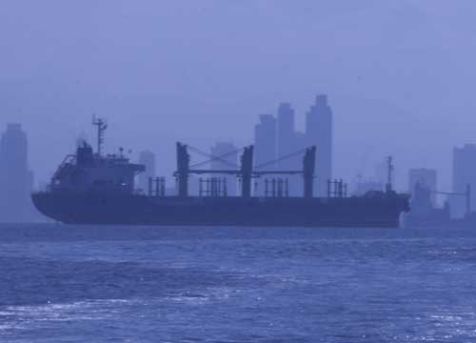
​​The amendments to the LLMC Protocol 1996 raise the amount claimable for loss of life or personal injury on ships (not exceeding 2,000 gross tonnage) to 3.02 million Special Drawing Rights (SDR), up from 2 million SDR (additional amounts are claimable on larger ships).

​Amendments to increase the limits of liability in the 1996 Protocol to amend the Convention on Limitation of Liability for Maritime Claims, 1976 (LLMC Protocol 1996) enter into force today (8 June 2015), raising the amount claimable for loss of life or personal injury on ships (not exceeding 2,000 gross tonnage) to 3.02 million Special Drawing Rights (SDR), up from 2 million SDR (additional amounts are claimable on larger ships).

The 1976 LLMC Convention sets specified limits of liability for certain types of claims against shipowners:

- Claims for loss of life or personal injury, and
- Other claims, such as property claims (including damage to other ships, property or harbour works), delay, bunker spills, pollution damage, etc.

The Convention also allows for shipowners and salvors to limit their liability except if "it is proved that the loss resulted from his personal act or omission, committed with the intent to cause such loss, or recklessly and with knowledge that such loss would probably result".

Taking into account the experience of historic claims, as well as the impact of inflation rates, the limits in the LLMC Protocol 1996 were raised and subsequently adopted in 2012 by IMO’s Legal Committee when it met for its 99th session, following a proposal to increase the limits submitted by 20 State Parties to the LLMC Protocol.

The LLMC Protocol has 50 Contracting States, which between them represent 57.41% of the world merchant shipping tonnage (as at 8 June 2015).

New limits:
The amendments to the LLMC Protocol 1996 raise the limits as follows:

The limit of liability for claims for loss of life or personal injury on ships not exceeding 2,000 gross tonnage is 3.02 million Special Drawing Rights (SDR) (up from 2 million SDR).
For larger ships, the following additional amounts are used in calculating the limitation amount:
• For each ton from 2,001 to 30,000 tons, 1,208 SDR (up from 800 SDR)
• For each ton from 30,001 to 70,000 tons, 906 SDR (up from 600 SDR)
• For each ton in excess of 70,000, 604 SDR (up from 400 SDR).
The limit of liability for property claims for ships not exceeding 2,000 gross tonnage is 1.51 million SDR (up from 1 million SDR).

For larger ships, the following additional amounts are used in calculating the limitation amount:
• For each ton from 2,001 to 30,000 tons, 604 SDR (up from 400 SDR)
• For each ton from 30,001 to 70,000 tons, 453 SDR (up from 300 SDR)
• For each ton in excess of 70,000 tons, 302 SDR (up from 200 SDR)

Special Drawing Rights
The daily conversion rates for Special Drawing Rights (SDRs) can be found on the International Monetary Fund (IMF) website: http://www.imf.org/​)​
​​​

IMO – the International Maritime Organization – is the United Nations specialized agency with responsibility for the safety and security of shipping and the prevention of marine pollution by ships.
Web site: www.imo.org

